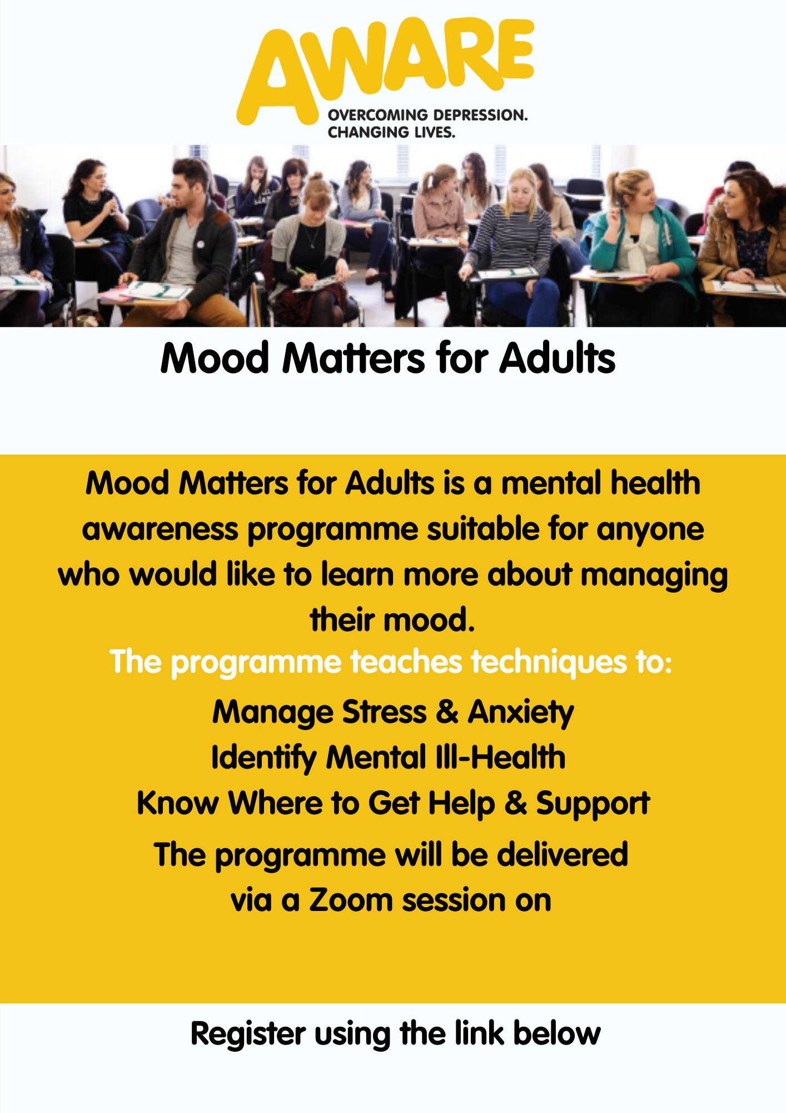

**To register please contact**

**Eileen.young@setrust.hscni.net**



https://aware-ni-org.zoom.us/meeting/register/tZwvdu2tpz4uGtKTjJIDujtD3KEC11sz482O

**Thursday, 30th September, 10am**